

Request for Quotes
Infrastructure Human Resources (HR) Strategy
(Consultancy Contract)

The Cook Island Investment Corporation (CIIC), in its capacity as the secretariat for the Infrastructure Committee (IC) and the Project Coordination Committee (PCC), wishes to engage a Consultant (or team of Consultants) to develop a Infrastructure Human Resources (HR) Strategy for the public infrastructure sector in the Cook Islands.
The Scope of the Services is detailed in the attached Terms of Reference.
Key Dates
Deadline for submission of Quotes: | Sunday 29 March 2026, 4.00pm (CI Time)
Contract award notification date: | Friday 10 April 2026
Services start date: | Wednesday 15 April 2026

Quote submission requirements:
Interested consultants must submit the following documents:
- Cover Letter (confirming availability, interest, expertise summary)
- Company/Consultant Profile (relevant projects, certifications)
- Methodology & Work Plan (approach & timelines)
- CVs of Key Personnel
- Completed Pricing Template
- Completed Conflict of Interest Declaration Form
Submission Address: by email to lea.raymond@cookislands.gov.ck

Conditions of Quotes
- Contents of this RFQ
This RFQ consists of:
- Cover page
- Conditions of Quotes
- Attachment 1: Terms of Reference
- Attachment 2: Forms to be submitted
- Attachment 3: Draft Contract
- Attachment 4: Concept Plan
- Communications regarding this RFQ
All correspondence and questions relating to this RFQ must be in writing via email and directed to the named Contact Person below.
Contact Person for this RFQ:
Lea Raymond
Cook Islands Investment Corporation
Email address: lea.raymond@cookislands.gov.ck
- Registrations of Interest
Prospective respondents should register their interest to participate in this RFQ process by emailing the Contact Person.
Only registered respondents will receive notices to this RFQ directly, if or when issued. It is the responsibility of the respondent to ensure they are properly registered for this RFQ.
- Notices to this RFQ
Notices to this RFQ, if/when issued, will be distributed by email to registered respondents.
- Quote contents
Quotes must comprise of the documents itemised on the cover page. Respondents may submit additional information in support of their Quote.
All Quotes must be firm offers and may not be withdrawn for a period of 30 calendar days following the deadline for submission of Quotes.
Respondents must conform to these Conditions of Quotes, and CIIC reserves the right to reject any non-conforming Quote.
- Submission of Quotes
Quotes must be received by the deadline specified on the cover page of this RFQ. Quotes received after the deadline may not be considered.
Quotes must be submitted in electronic format only, in pdf format (or otherwise in a format compatible with Microsoft Office).
Quotes must be submitted by email to lea.raymond@cookislands.gov.ck
- Confidentiality
Respondents are advised that CIIC is subject to the Official Information Act 2008. Respondents should mark their Quotes “Commercial - In Confidence” if they wish to protect specific information. CIIC will treat all Quotes in confidence. CIIC cannot however guarantee that information marked as Commercial – In Confidence can be protected if CIIC receives a request for information under the OIA.
- The RFQ Process
Each respondent shall examine, or be deemed to have examined, the Conditions of Quotes, Terms of Reference and Assessment Criteria and any other information supplied by CIIC via email.
In submitting a Quote in response to this RFQ, the respondent accepts and agrees to be bound by these Conditions of Quotes.
All costs of preparing and submitting the Quote shall be borne by the respondent.
CIIC reserves the right to change, suspend, cancel or reissue this RFQ, or the contents of the RFQ documentation at any time.
CIIC shall have no liability for any information it provides, or for any cost or loss to any respondent, in the event that this RFQ is cancelled, suspended, changed or reissued.
CIIC reserves the right to negotiate without restriction with respondents after the close of the RFQ on any matter contained in the Quote, without disclosing this to any other person.
CIIC reserves the right to accept or reject any or all Quotes, at any time prior to any contract being awarded.
- Evaluation of Quotes
Quotes will be assessed against the following criteria:
Criteria | Weight (%) | Sub-Criteria
Availability and timeliness | Pass/Fail | Timelines are within the required period
Technical Expertise | 40% | HR, strategy development, public sector
Relevant Experience | 30% | Years of experience, Pacific projects
Cost Competitiveness | 30% | Transparency, value for money

CIIC may request additional information from any respondent before accepting any Quote, or implement additional processes to evaluate the Quote.
Each respondent shall be notified in writing as to whether or not it has been selected as the preferred Respondent as soon as possible. No Quote shall be deemed to be accepted unless and until the respondent has been notified by CIIC in writing.
CIIC reserves its absolute discretion in the evaluation and selection process.
- Subject to Contract
Quotes are submitted on the basis that no binding legal relations with CIIC are created unless and until a formal written contract is signed by both CIIC and the successful respondent.
The acceptance by CIIC of any Quote, whether with or without negotiation, or the negotiation with an unsuccessful respondent, shall not create binding legal relations between CIIC and the party whose Quote has been accepted or which is negotiating with CIIC.
If, in the opinion of CIIC, and at CIIC’s sole discretion, none of the Quotes submitted are acceptable, CIIC reserves the right to enter into negotiations with one or more of the respondents for a satisfactory offer.
- Governing law
This RFQ is governed by Cook Islands law, and the Cook Islands courts have exclusive jurisdiction to all matters relating to this RFQ.
- Contract Negotiations
Both parties agree to negotiate in good faith, and on successful conclusion of negotiations the preferred Respondent will sign a formal contract with CIIC.
A contract may be extended if additional work is required, at CIICs sole discretion.
- Non-Resident businesses
In order for foreign companies to carry out business in the Cook Islands, an application for, and approval, must be sought from the Business Trade Investment Board (BTIB). Any fees associated with the registration are to be covered by the successful Consultant. Respondents should inform themselves of the registration process and confirm in their Quote that they are willing to register once a Letter of Acceptance is issued. Information can be found at www.btib.gov.ck.
- Cook Islands Tax Laws
Respondents should inform themselves of the Cook Islands tax laws including Value Added Tax (VAT) applicable to businesses registered in the Cook Islands, and non-resident withholding taxes applicable to foreign businesses for services delivered externally of the Cook Islands.



Attachment 1:
The Cook Islands Infrastructure HR Strategy (The Strategy) for the Public Infrastructure Sector
Terms of Reference (TOR)

Executive Summary
The purpose of this Terms of Reference is to support the development of an Infrastructure HR Strategy (the Strategy) for the public infrastructure sector in the Cook Islands.
The expectation is that a practical, simple and relevant strategy will be developed that includes a “strategy on a page” that will support infrastructure leaders and managers to easily and effectively build engagement within their respective organisations and agencies.
The Strategy will be supported by a detailed SMART implementation action plan that will drive tangible action and improvement. It will also support a culture of accountability and ownership.
The implementation plan will be linked to a monitoring plan that fosters an environment of accountability for implementation of the Strategy. This will include a framework for routine and transparent performance reporting and for creating linkages to the appraisal of senior leadership and management’s performance.

Project Details:
Project Title: Infrastructure HR Strategy (the Strategy)
Commissioning Parties: The commissioning party for the Infrastructure HR Strategy Terms of Reference is the Cook Island Investment Corporation (CIIC) in its capacity as the secretariat for the Infrastructure Committee (IC) and the Project Coordination Committee (PCC).
Purpose: Develop a strategy that provides a roadmap for transforming the Cook Islands infrastructure sector. The Strategy will aim to:
- Attract people to work in the infrastructure sector
- Improve labour force retention and reduce turnover
- Develop a skilled and adaptable workforce and with a focus on the local market
- Foster a culture of continuous learning and professional development
- Identify other interventions that reduce pressure on the labour force
- Anticipate future workforce, technological, digital and other trends such as Climate change threats and adaptation.

Introduction
The Cook Islands infrastructure sector faces significant challenges, including aging infrastructure and workforce, a shortage of skilled workers, attraction, retention and upskilling of skilled staff.
To address these challenges, the government and industry stakeholders require a comprehensive strategy that promotes attraction, staff wellbeing, skills development, and labour force retention.
The purpose of the Infrastructure HR Strategy (the Strategy) is to provide a roadmap for transforming the Cook Islands infrastructure sector. The strategy aims to:
- Improve labour force retention and reduce turnover
- Develop a skilled and adaptable workforce with a focus on the local market
- Foster a culture of continuous learning and professional development
- Identify other interventions that reduce pressure on the Labour force
- Anticipate future workforce, technological, digital and other trends, such as climate change threats and adaptation.

Context and Current State
The public infrastructure sector in the Cook Island comprises a mixture of government ministries and state-owned enterprises.
- Refer to Appendix A for an overview of the Cook Islands infrastructure sector public entities.
- Refer to Appendix B for a list of key stakeholders that should be engaged with to develop the Strategy.
In developing this Terms of Reference, the PacificTA assignment team engaged with a range of key stakeholders to appropriately define the scope of the Strategy.
- Refer to Appendix C for the observations and insights of the PacificTA assignment team.
Not all key stakeholders were available to meet with the PacificTA assignment team. Therefore, further engagement with key stakeholders will be required during the Strategy’s development.
During the engagement with key stakeholders whilst developing this Terms of Reference, it was apparent that there is a plethora of similar initiatives either underway or about to commence. There is a significant opportunity to utilise work already completed and to rationalise future planned work to reduce duplication, waste and fragmentation.
Refer to Appendix D for a schedule of other relevant plans, policies and initiatives related to HR strategies and workforce development that should be given due consideration.
In developing this Terms of Reference several other relevant and important documents have been identified that must also be given consideration during the literature review stage and during the development of the Strategy.
Most notable is the Cook Islands Government Functional Review – Report, Implementation Plan and Recommendations authored by Iain Rennie. Of particular note are the recommendations related to:
- Developing a national HR strategy for the public sector
- The progressive adoption of shared services hubs
- Moving to a common approach to performance management for CEOs and transparency with respect to entity performance across the public sector.
Refer to Appendix E for a schedule of documents that must be encompassed in the literature review stage. Note that this is not an exhaustive list and there may be further discovery work.

Scope and Deliverables
This section outlines the scope and deliverables for the development of the Strategy.

Scope of the Infrastructure Sector
The scope of the Strategy is restricted to the public portion of the infrastructure sector.

Vision & Goals
The Strategy must contain a clear vision statement that describes the future state of the Cook Island Infrastructure Sector and aligns with the visions of the sector organizations and be appropriate for the Cook Islands context (i.e., consider cultural norms, customs and way of life).

Governance & Leadership
Given the importance of organizational leadership and how the “tone from the top” shapes culture, the strategy should address Leadership as a cross-cutting theme. Specifically, the Strategy should:

- Foster an environment of accountability
- Facilitate transparent performance reporting
- Integrate leadership capability as a critical skillset for governors and maintain a pool of suitable talent to be appointed to the boards of SOE’s that develop, operate, or maintain public infrastructure. Similarly, for management roles leadership capabilities should be integrated as a critical skillset consistently in Job Descriptions.
- Create linkages between implementation of the Strategy and the performance monitoring and management of HOM’s and CEO’s in the and their respective entities (consistent with OPSC approaches)
- Ensure any performance monitoring incentivizes inter-agency/entity collaboration and cooperation
- Provide a structured approach to upskilling emerging and middle tiers of management with people leadership skills
- Suggest suitable people-related metrics that can be used to measure the outcome of the strategy’s implementation.

Strategic Themes
The Strategy must:
- Give effect to the Cook Island Government’s National Sustainable Development Agenda
- Align to the Terms of Reference for the National Workforce Development Plan, and
- Give effect to the vision, purpose and values of the infrastructure organisations.
The Strategy should be themed into the following pillars:
Attract:
- Workforce planning to identify required capabilities and skills
- Prioritisation of roles
- Defining the employee value proposition to attract talent
- Reevaluate remuneration and salary banding so that the infrastructure sector is able to compete for talent
- Actively identify and engage with current and future talent pools to ensure a pipeline of candidates for the future
- Identify opportunities for the infrastructure sector to partner and collaborate with the education sector to develop a long-term pipeline of talent
- Develop a consistent candidate-centric recruitment process.

Develop:
- Identify critical capabilities and establish appropriate training opportunities and upskilling initiatives
- Develop and implement clear career pathways to provide workers with structured and progressive opportunities with a corresponding remuneration framework for technical pathways
- Ensure leadership programmes are in place
- Adopt a consistent sector-wide performance management framework (bearing in mind the role of OPSC in performance management).

Retain and Engage:
- Foster a culture of reward and recognition of success
- Building workforce engagement
- Build and sustain a culture and working environment that promotes safety, health, wellbeing, diversity, inclusion and belonging.

Refer to Appendix F which provides a model example of a graphical pipeline of talent that spans the above three themes. This model embeds a partnership approach between with the infrastructure and education sectors.

Balancing Supply & Demand
The Strategy, which will manage the supply of workforce capability & capacity, cannot sit in isolation. It must respond to the workforce capability and capacity demands generated by the National Infrastructure Investment Plan (NIIP), programmes of projects and four-year budget cycles.
The Strategy needs to be a reciprocal feedback loop in order to balance supply and demand. Whilst the Strategy is an enabler to successfully delivering plans and programmes of projects, the scope and scale of these plans and programmes need to be moderated to match the current capability and capacity of the workforce.

Future focus
Anticipate and evaluate mega trends on emerging ways of work that leverage technology, digital and AI ways of working. Identify those opportunities with potential, and those that do not and should be discarded.

Key Components of the Infrastructure HR Strategy
The key components that comprise the Strategy will include:
- A detailed Strategy Document written in simple practical language that contain references to key documents. The purpose is to record the background research and demonstrate the substance behind the recommendations and actions included in the strategy.

- A one-page graphic Summary Document “Strategy on a page”.
It should be able to be summarised in a concise one-page overview that is visually appealing and easily accessible with a mix of key words and graphics. The purpose is to make the strategy accessible easy to communicate build organisational engagement for implementation.

- An Implementation Action Plan with Specific, Measurable, Achievable, Relevant, and Time-bound (SMART) goals for transformation, labour attraction, skills development, and labour force retention. The purpose is to elicit ownership of the Strategy by infrastructure leadership/management and motivate them to deliver tangible action.

- A Monitoring and Reporting Plan which fosters an environment of accountability and transparency of performance reporting.

Implementation Monitoring Plan
Alongside the implementation action plan, a monitoring plan should be developed. The monitoring plan must provide a framework for:
- Fostering a culture of accountability for the implementation of the Strategy
- Creating linkages between implementation of the Strategy and the performance expectations of senior leadership in the infrastructure sector
- Routine and transparent reporting on the implementation action plan.
- Continuous improvement and regularly reviews of the Strategy so that it remains current and relevant to the current infrastructure HR issues and opportunities.

Excluded from Scope
The following matters are excluded from the scope of the Strategy:
- The workforce of private sector companies that contract with the Cook Island infrastructure sector
- Social Infrastructure outcomes procured by the Ministries of Education and Health
- Changes to the open-door policy with New Zealand
- Identification of funding sources, as this has already been completed as a desk and will be executed by CIIC.

Methodology & Timeline
It is expected that the strategy development process will include the following key steps and associated timeframes:
- Literature review and research
- Stakeholder engagement and consultation (ideally approved by CIG)
- Workforce analysis and skills gap assessment
- Development of comprehensive strategy document
- Test strategy with key stakeholders and invite feedback
- Distil into a strategy on a page
- Develop a SMART Action Plan and test proposed actions with key stakeholders
- Monitoring & reporting plan
- Presentation of final report.
It is expected that this above work will require no more than 8 weeks to complete.
To ensure local ownership, strengthen institutional HR capability, and support long-term implementation of the Infrastructure HR Strategy, the consultancy team will work closely with a designated Cook Islands Government HR professional as a local counterpart throughout the assignment. The purpose of this pairing is to build practical skills, confidence, and a clear understanding of the HR processes, tools, and methodologies applied, enabling the counterpart to support the future roll-out of key initiatives. This requirement complements—but does not alter—the consultant’s full responsibility for delivering all outputs, and suppliers must include in their proposal a brief capacity-building and skills-transfer plan embedded within existing tasks (no standalone training modules required).

Acknowledgements
Project Coordination Committee would like to thank the PacificTA Assignment team (Adrienne Miller (Lead), Mary Johnston (HR SME), David Langford (Engineering Infrastructure SME)) for developing the Terms of Reference.

Appendices
- Appendix A: Organisation Charts
- Appendix B: Key Stakeholder Schedule
- Appendix C: PacificTA Assignment team Insights
- Appendix D: Schedule of other HR & Workforce Development Initiatives, plans and policies
- Appendix E: Other documents, plans etc. to be included in the literature review stage
- Appendix F: Talent Pipeline Model
- Appendix G: Schedule of Acronyms
Appendix A: Organisational Chart(s)
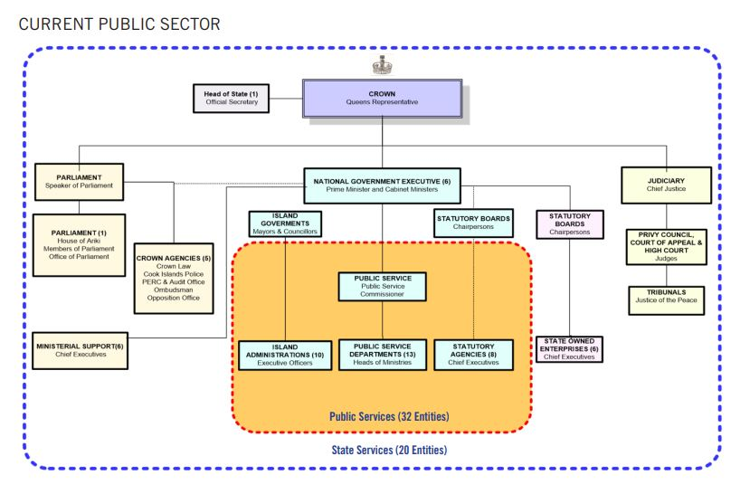
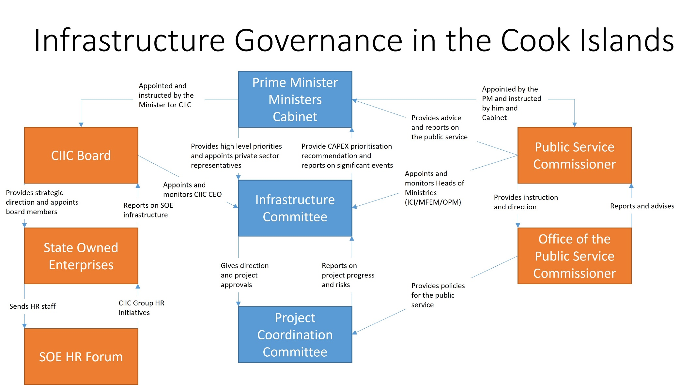
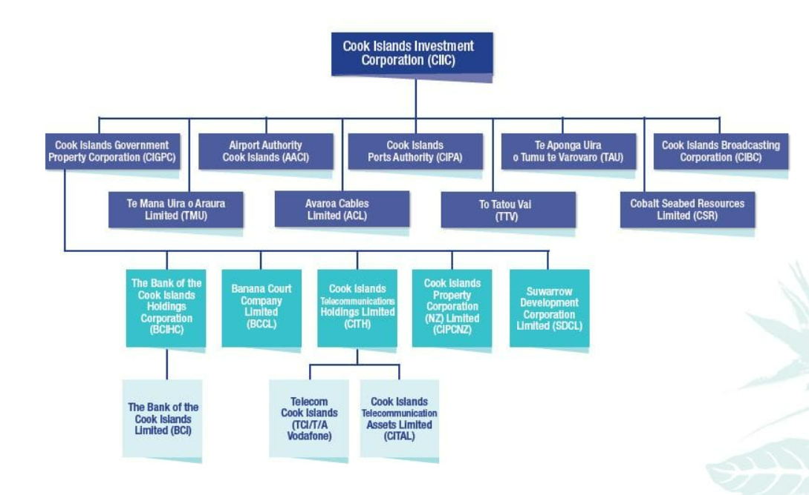
Appendix B: Key Stakeholders for Strategy development

Key Stakeholders | Organization | Name | Position | Email | Meeting Completed
Project Coordination Committee (PCC) | Cook Islands Investment Corporation | Lea Raymond* (Chair) | Government Facilities Manager | Lea.raymond@cookislands.gov.ck | 30 April 2025
 | Cook Islands Investment Corporation | Anne Taoro* | General Manager, Asset Development Division | Anne.taoro@cookislands.gov.ck | 30th April 2025
 | Cook Islands Investment Corporation | Mereani Talbot* | Secretariat / Infrastructure Analyst | Mereani.talbot@cookislands.gov.ck | 28th April to 2 May 2025
 | Ministry of Finance Economic & Management | Angelia Williams | Major Procurement & Projects, Director | Angelia.williams@cookislands.gov.ck | N/A
 | Ministry of Finance Economic & Management | Andre Tuiravakai | Client Representative | Andre.tuiravakai@cookislands.gov.ck | N/A
 | Ministry of Finance Economic & Management | Anthony Tautala* | Senior TVP Advisor | Anthony.tautala@cookislands.gov.ck | 29th April, 2 May
 | Infrastructure Cook Islands (ICI) | Kiri Ataera* | Director Planning & Implementation | Kiri.ataera@cookislands.gov.ck | 30th April, 2 May
Additional attendees for the PCC workshop | Cook Islands Investment Corporation | Cain Rakanui* | Project Manager | cain.rakanui@cookislands.gov.ck | 30th April 2025
 | Cook Islands Investment Corporation | Rebecca Cutler* | CIIC ATOM Project Coordinator | rebecca.cutler@cookislands.gov.ck | 30th April 2025
Infrastructure Committee (IC) | Cook Islands Investment Corporation | Allan Jensen* | CEO | Allan.jensen@cookislands.gov.ck | 30th April, 2 May
 | Infrastructure Cook Islands (ICI) | Elizabeth Koteka-Wright* | Head of Management – Secretary of ICI | Elizabeth.koteka-wright@cookislands.gov.ck | 30th April
 | Tamanu Resort | Mike Henry | Business Owner | Michael.henry@cookislands.gov.ck | N/A
 | Ministry of Finance Economic & Management (MFEM) | Garth Henderson*  Leanna Chappell -Kairua* | Head of Management – Secretary of MFEM  Corporate Manager | Garth.henderson@cookislands.gov.ck | 28th April  28th April  2 May
 | Consultant | Sam Brown | Consultant – Surveyor / Engineer | sam@miroconsultants.com | N/A
 | Office of the Prime Minister | Karopaerangi Ngatoko* | Chief of Staff | karopaerangi.ngatoko@cookislands.gov.ck | 1st May
State Owned Enterprise (SOE) | Ports Authority | Marina Andersen Rima* | Finance & Administration Manager | marina.rima@cookislands.gov.ck | 28th April
 | Ports Authority | Bernadette Teremoana* | Finance & Administration Officer | bernadette.teremoana@cookislands.gov.ck | 28th April
 | Airport Authority | Moari Fortes Ngamata | HR Manager | moari@airportauthority.gov.ck | N/A
 | Airport Authority | Leon Potoru* | HR Assistant | lpotoru@airportauthority.gov.ck | 28th April
 | Avaroa Cable | Fiona Pearson | Business Operations Manager | fiona.pearson@avaroacable.com | N/A
 | Te Aponga Uira | Iliesa Sasala* | HR Manager | ISasala@electricity.co.ck | 28th April
 | Bank of the Cook Islands | Jean Francis | HR Officer | jean.francis@bci.co.ck | N/A
 | Seabed Mineral Research | Eusenio Fatialofa | General Manager | general.manager@ciic-sr.co.ck | N/A
 | Cook Islands Investment Corporation | Poko Heather* | HR Manager | poko.rongo@cookislands.gov.ck | 28th April
 | Bank of the Cook Islands | Mii Mataora* | HR Manager | mii@bci.co.ck | 28th April
 | Cook Islands Investment Corporation | Sierra Garner | HR Officer | sierra.garner@cookislands.gov.ck | N/A
Other SOE CEO’s | To Tatou Vai | Apii Timotii | CEO | atimoti@totatouvai.co.ck | N/A
 | Te Aponga Uira | Lesley Katoa | CEO | LKatoa@electricity.co.ck | N/A
 | Avaroa Cable | Mike Schwarz | CEO | mike.schwarz@avaroacable.com | N/A
 | Ports Authority | Okosene Moananu* | CEO | okesene.moananu@cookislands.gov.ck | 29th April
 | Airport Authority | Nikau Tangaroa | CEO | nikautangaroa@airportauthority.gov.ck | N/A
Other Key Stakeholders | Ministry of Education | Owen Lewis | Head of Management, Secretary of Education | secretary@education.gov.ck | N/A
 | Cook Islands Institute of Training | Tania Morgan | Director | Director@citti.edu.ck | N/A
 | Public Service Commissioner | Carl Hunter* | Public Service Commissioner | carl.hunter@cookislands.gov.ck | 30th April
 | Public Service Commissioner | Myra Patai* | CEO | myra.patai@cookislands.gov.ck | 30th April
 | Public Service Commissioner | Tepaeru Tauraki* | HR Manager | Tepaeru.tauraki@cookislands.gov.ck | 30th April
 | Public Service Commissioner | Dorothy Solomona* | Policy Manager | Dorothy.solomona@cookislands.gov.ck | 30th April
 | Asian Development Bank | Lavinia Tama* | Senior Country Officer | ttama@adb.org | 1 May
 | Cook Islands National Labour Advisory Board (NLAB) | Chair: INTAFF HOM, Members: OPS Commissioner, MFEM HOM, IMMIGRATION PRINCIPAL, FOREIGN AFFAIRS DIRECTOR TMOD, CHIEF INSPECTOR LABOUR; Cook Islands Workers Association – 3 reps; Chamber of Commerce – 3 reps

*Indicates a meeting occurred with the PacificTA Assignment team members. Dates shown are key meetings. Some incidental follow ups also occurred
Appendix C: Impressions & Observations of PacificTA Assignment team.
The following section groups together under thematic headings the feedback the PacificTA assignment team heard during their visit. These are para-phrased summaries, not verbatim. They have been taken at face value and the assignment team have not undertaken any work to verify if they are real or perceived.
Positives
- There are some highly skilled people who have the experience and the right skillset.
- There is a desire for change and to better serve organisations and community (with covid having changed ways of working and opened possibilities).
- Pockets of excellent practice identified.
- There is an understanding of the need to reduce duplication and share best practice and the need to move beyond inconsistency/variance between in policies, procedures, approaches, tools and systems.
- Flexible hours and working from home type arrangements were available in some workplaces.
- There are some retention strategies in place, such as additional allowances, bonuses, secondments and additional compensation for people acting up or in trial acting roles.
- Receptiveness to shared service model (so long as the queue system was resolved). A hub model for transactional-type tasks could be effective as per the recommendations from the Functional Review.
- Many examples of wellbeing initiatives provided by interviewees.
- Horizontal structures provide opportunities for more responsibility and on-the-job learning.

Remuneration & rewards
- A focus on monetary drivers (stability and status of public sector roles less a driver than in the past).
- Benefits in the form of free power, superannuation, insurance, health checks, leave (including travel/boat leave) training etc exist and could be better leveraged as incentives.
- Inconsistent practice regarding using unspent wages and salaries budgets (due to vacancies); some managers and agencies are reallocating unspent funds to bolster remuneration.
- “Salary banding is just not right”.
- Robust job descriptions are required for the job sizing exercise.
- “Strategic Pay do not understand our context and market conditions”.
- Pa Enua (outer island) consideration: hourly rates themselves could be good, but number of hours insufficient and meant supplemental income/support required.
- Cost of living and quality of schooling for the next generation are key concerns.
- Large number of vacancies – some sources commented that this could be as high as one in three roles unfilled. Workforce overloaded with multiple roles and unremunerated responsibilities. Some suggestion that the budgets for vacant roles are used to pad budgets for other uses or balance the books elsewhere.
- Can earn more in NZ or AUS for manual work such as fruit picking or meat works
Loss of workforce
- Retention issues were widely cited by most stakeholders that were engaged with.
- Loss of workforce to Australia and New Zealand (wages/opportunities/ training/ land ownership/better lives for next generation). NB: “Open door” policy with NZ is having unintended negative impacts given variance in minimum wages environment ($9 -14/hour in CI versus $45/hour for NZ entry level primary sector roles – “and they return with no new skills for CI”).
- The Australian mining sector is a large draw for people to leave Cook Islands.
- We heard that there is a misalignment between maternity leave allowances and the availability of formal childcare arrangements that makes it difficult for new mothers to return to the workplace until child is 1 years old – this is a potential underutilised talent pool.
- A secondary impact of the loss of Cook Islanders to other jurisdictions is that friends and family wishing to visit them have increased need for leave.

Pathways, training, development
- Need for more strategic upskilling of workforce. Funding and lack of staff time cited as reasons for absence of internal training.
- Various upskilling and training opportunities not always widely notified for uptake across the entire workforce, remaining instead with individual agencies.
- Need mechanism for recognising non classroom based vocational experience and capability and creating parity for that learning with formally trained workers.
- Some expressed the view it was not worth undertaking training because of forgone earning opportunity because they then “go back to the starter-level wage/salary anyway”.
- Some variance in levels of HR expertise/skills across organisations with staff having spilt roles (also having responsibility for other functional areas).
- Formal career pathways within organisations need creating. One comment that expats are a “lazy solution”, with the hard work now paying off in the long term when workplaces “knuckle down and do the hard yards” on developing pathways.
- Some resistance by locals to the need to continually train up and assimilate expats.
- Expats often used to fill gaps where local expertise lacking – often costing more and requiring greater upskilling and integration, with tenure extracted often only 2-3 years.
- Ageing workforce and knowledge transfer mechanisms informal if they exist at all.
Leadership & Culture
- A recognition that senior leaders who take accountability for, and drive, HR initiatives in combination with good HR capability is a critical success factor.
- Using corporate mission, vision and purpose statements to build engagement with the workforce is inconsistent. This is a potentially underutilised lever for recruitment and retention and for creating a sense of purpose and meaningful work.
- Culture and engagement surveys are inconsistently used. Where they are used, themes from the verbatim comments should be used to drive targeted improvement actions.
- Wellbeing initiatives tend to be limited to physical health and social activities. As a result, they lack depth to address more holistic wellbeing, including mental health, stress, burn-out, addiction and alcohol misuse.
Duplication, fragmentation and collaboration
- The Functional Review by Iain Rennie is a substantial piece of work and the sector will benefit from its implementation.
- Some progress made in developing collaborative groups for HR, but still evidence of siloed behaviour and little inter-agency collaboration/sharing.
- Territorialism and patch protection are evident in some organisations.
- Opportunity to pool tools and resources.
- Multiple agencies and entities are all trying to solve the same problem and duplicating effort – this is a major waste.
- Some entities/ agencies are forging ahead because they can’t wait for others and are frustrated because they want it finished.
- Some share their good practice but the receiving audience can quickly disengage because of lack of resources or feeling overwhelmed.
Systems processes technology
- HR Systems and tools developed individually rather than centrally.
- There is a good suite of tools developed by MFEM.
- Public service templates for things such as performance reviews are useful.
- HRINZ provide good resources (tools & templates).
- NZ State Services Commission provides good HR resources (tools & templates).
- Public Service Fale (funded by MFAT) provides good HR resources (tools & templates).
- Some use of Artificial Intelligence (AI) observed to support development of plans strategies, job descriptions and other documents.
Societal Issues
- Absences and productivity at times impacted by out of work socialisation.
- Homeownership challenges (Cook Island land tenure permits leasehold only for those not from Rarotonga).
- Language barrier for Indonesian workers (Fijian and Philippine imported labour less of an issue).

Appendix D: Schedule of existing policies, plans, and initiatives related to infrastructure development and workforce development
- National workforce development plan (public service commission)
- Bank of Cook Islands working with Mosaic to develop HR strategy
- Functional Review by Ian R including the recommended HR Strategy
- MFEM Recruitment & Retention Plan.
- Work conducted by Cook Islands National Labour Advisory Board (NLAB)
a tripartite board composed of members of the Government, the Chamber of Commerce as the employers’ representative and the Cook Islands Workers Association as the employees’ representative
- Asian Development Bank– Strengthening capability
- Review of the Public Services Act 2009
- Recruitment Process V1.0
- (MFEM) Standard job description template
- Critical Vacancies – Meeting Questions
- MFEM Vacancies MFEM 20250202.xlsx

Appendix E: Non exhaustive list of other documents and information to be reviewed at the literature review stage of the strategy development:
- Cook Islands Government National Sustainable Development Agenda 2021-2121
- Cook Islands Government Functional Review – Report, Implementation Plan and Recommendations authored by Iain Rennie
- Cook Island Investment Corporation Statement of Corporate Intent 2025
- Infrastructure Cook Islands Te Akamouanga Kaveinga; Statement of Strategic Intentions 2023-27
- National Infrastructure Investment Plan (NIIP)

Appendix F: Example model for engaging with education to build a pipeline of talent:
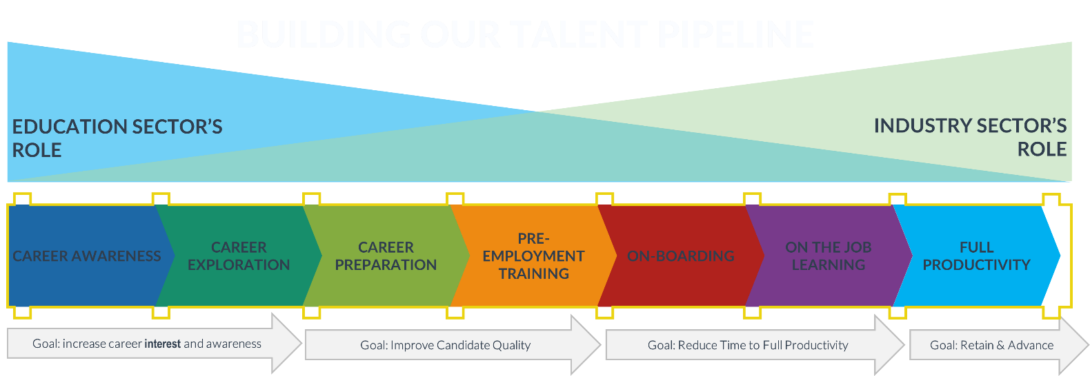
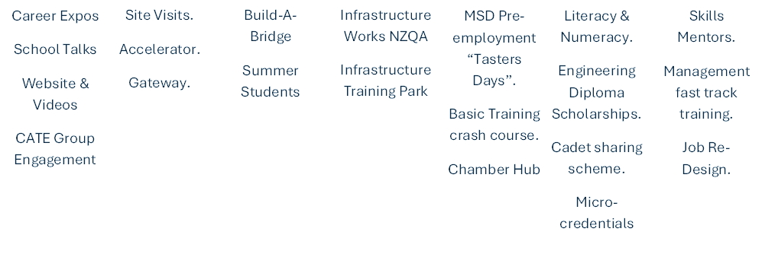

Appendix G: Schedule of Acronyms
- CIG Cook Islands Government
- OPM Office of the Prime Minister
- IC Infrastructure Committee
- PCC Project Coordination Committee
- OPSC Office of the Public Services Commission
- MFEM Ministry of Finance and Economic Management
- CIIC Cook Islands Investment Corporation
- ICI Infrastructure Cook Islands
- ADB Asian Development Bank
- EDS Economic Development Strategy
- SOEs State Owned Enterprise(s)
- CIGPC Cook Islands Government Property Corporation
- AACI Airport Authority Cook Islands
- CIPA Cook Islands Ports Authority
- TAU Te Aponga Uira o Tumu te Varovaro
- CIBC Cook Islands Broadcasting Corporation
- CSR Cobalt Seabed Resources Limited
- TTV To Tatou Vai
- ACL Avaroa Cables Limited
- TMU Te Mana Uira o Araura Limited
- BCI The Bank of the Cook Islands Holdings
- BCCL Banana Court Company Limited
- CITH Cook Island Telecommunications Holdings Limited.
- CICNZ Cook Islands Corporation (NZ) Limited
- SDCL Suwarrow Development Corporation Limited
- BCI The Bank of the Cook Islands Limited
- TCI Telecom Cook Islands
- CITAL Cook Islands Telecommunication Assets Limited

Attachment 2:

FORMS TO BE SUBMITTED
Infrastructure Human Resources (HR) Strategy

- Pricing Template

RESPONDENT TIPS: Submit your financial information and pricing using the following pricing schedule.
- All amounts are to be in New Zealand dollars and to be exclusive of CI Value Added Tax.
- Provide insurance details, if any.

No. | Stage / Deliverables | Fixed Fees (NZ$)
1
2
3
4
5
6
TOTAL FEES exclusive of VAT
VAT
Total

Our Professional Indemnity Insurance Details
Item Detail
Insurer: | [name of current insurer]
Limit of indemnity: | [state the amount]
Conditions: | [state the conditions]

Assumptions
State any assumptions you have made in relation to the cost and pricing information.

- Conflict of Interest Declaration

A conflict of interest arises if you or a close family member has an interest e.g. is a board or committee member or is employed in a senior position in the Government agency that wants to purchase the goods or services relating to this RFQ process.
In submitting this Quote I declare:
- That I understand an actual, potential or perceived conflict of interest may arise in participating in this Quote process and that I am obliged to declare any such conflict of interest.
- That in submitting this information that I have either declared any potential conflicts of interest or that I am not aware of any situation or issue that would conflict with the interest of the CIIC.
- If a conflict of interest arises at any time before the selected Respondent has been awarded the contract, I will advise the CIIC immediately.
- I have personally completed this declaration on behalf of the Respondent and declare that the submitted Quotes provided are true and correct.
I declare that I have a potential conflict of interest as follows:
I will manage this conflict of interest by:
Declared by:
Signature |  | Date
Full Name |  | Position (if Company)

Attachment 3:

DRAFT CONTRACT
For Reference Only.


Schedule
PRINCIPAL: Cook Islands Investment Corporation
Signed: _____________________________
Name: Allan Jensen
Position: Chief Executive Officer
Date:

CONSULTANT:
Signed: _____________________________
Name:
Position:
Date:
____________________________________________________________________________________
Project:
Location: | Rarotonga, Cook Islands
Scope and Nature of the Services:
Programme for the Services: | This engagement is for a period of XX months, commencing XXXX 2026 and ending XXXX 2026, unless extended in writing with the agreement of both parties.
Fees and Timing of Payments: | The Principal agrees to pay the Consultant the lump sum fees and expenses as follows:  Fees:  Fees shall be invoiced on a monthly basis or upon completion of the required Deliverables.  Timing of payments:  Unless disputed, payments will be made by bank transfer to the Consultant’s nominated account within ten (10) working days of receipt of an invoice.
  No. | Deliverable | Lump Sum Total Fee (NZD)
  Total
Insurances: | Professional Indemnity Insurance is five times the fee, with a maximum of $XXX.  Public Liability Insurance - $XXX
Liability: | The Consultant’s total liability to the Principal arising out of or in connection with this agreement (including the performance or non-performance of the Services) whether in contract, tort or otherwise, shall be XX times the fee (exclusive of taxes and disbursements) and a maximum limit of $XXX. Duration of liability is 6 years.
Principals Representative: | XXX
Consultants Representative and Key Personnel: | XXX

Terms and conditions for the engagement of a Consultant
The Cook Islands Investment Corporation, a body corporate established by the Cook Islands Investment Corporation Act 1998 (the “Principal") agrees to engage the Consultant and the Consultant agrees to provide the Services described in the Schedule on the following conditions:
- Application: These terms and conditions supersede any contrary provisions in any previous agreements between parties, written or otherwise. No right under these terms shall be deemed to be waived except by notice in writing by each party. In the event that any one or more of the provisions contained in these conditions are declared invalid by order, decree or judgment of any Court of competent jurisdiction, these conditions are to be read as if such provision had not been inserted.
- Services: The Consultant shall perform the Services as described in the attached Schedule in accordance with any requirements set out in these terms and conditions and/or in the Schedule. The time of performance of the Services is a fundamental element of these terms and conditions. The Consultant shall notify the Principal in writing immediately when the Consultant becomes aware there may be a delay in the delivery of the Services. The Principal is entitled to cancel these terms and conditions or change its specification (without incurring additional charges) if the Services are not supplied on the supply dates or times specified in the Schedule. Where the Consultant has the benefit of any warranties or covenants from a third party in respect of the Services, the Consultant shall disclose and assign the benefit of the warranties and/or covenants to the Principal.
- Skill: The Consultant shall use the highest reasonable standard of skill, care and quality and employ techniques, methods, procedures and materials of a high quality and standard in accordance with best professional practice in rendering the Services. The Consultant will comply with all relevant (a) Cook Island standards and international standards (if not in conflict) (both general and industry-specific); (b) statutes; (c) regulations; (d) by-laws; (e) ordinances; and (f) Government policies, applicable in respect of the supply of the Services. If in conflict, unless as otherwise agreed the Cook Islands standards shall prevail.
- Independent Judgment: Where the Services require the Consultant to certify, decide or use discretion under a contract between the Principal and a third party, the Consultant must act independently, and with professional skill and judgment, and according to the terms of the contract between the Principal and the third party.
- Delay: If at any time the Consultant's performance falls behind the programme set out in the Schedule then the Consultant shall notify the Principal and, where the delays are due to matters within the control of the Consultant, shall take all practicable steps to remedy such delay.
- Variations: The Principal may order variations to the Services in writing or may request the Consultant to submit proposals for variation to the Services. Where the Consultant considers a direction from the Principal or any other circumstance is or may give rise to a variation the Consultant shall notify the Principal as soon as practicable.
- Payment: The Principal shall pay the Consultant for their Services, the fees and expenses at the times and in the manner set out in the Schedule. The prices stated in the Schedule are fixed unless there is a written agreement stipulating the price may be varied, when it may be varied and how the price is to be determined. The price is exclusive of VAT. The Consultant is not entitled to claim any additional expenses, surcharges, margins or disbursements except if otherwise agreed in advance and in writing by the Principal.
- Withholding Taxes: If the Principal is required by law to deduct or withhold any taxes in respect of any amounts payable to the Consultant, the Principal will deduct the applicable taxes from each payment made to the Consultant, and the Consultant shall receive the net amount after the required deductions or withholdings have been made by the Principal. The Principal shall pay the deducted amounts to the relevant taxation authority or government agency in accordance with the applicable law. Notwithstanding the foregoing, any travel related expenses, as detailed in the Schedule, will be reimbursed to the consultant in full, without any deductions or withholdings.
- Liability: Where the Consultant breaches these terms and conditions, the Consultant is liable to the Principal for reasonably foreseeable claims, damages, liabilities, losses or expenses caused directly by the breach. Neither the Principal nor the Consultant shall be liable to the other under this Agreement for indirect, consequential or special loss, or loss of profit, however arising, whether under contract, in tort or otherwise.
- Contribution to Loss: If either Party is found liable to the other (whether in contract, tort or otherwise), and the claiming Party and/or a Third Party has contributed to the loss or damage, the liable Party shall only be liable to the proportional extent of its own contribution.
- Indemnity: The Consultant indemnifies the Principal in respect of all costs (including legal costs), claims, liabilities, losses, damage and expenses suffered or incurred by the Principal as a direct consequence of any unlawful, negligent, tortious, criminal, reckless or dishonest errors, acts or omission of the Consultant in the performance of its obligations under these terms and conditions. This indemnity survives the termination of these terms and conditions.
- Insurance: The Consultant shall take out and maintain at its own cost, at all times during the continuance of these terms and conditions, such insurances as specified in the Schedule. All such insurance shall be on such terms and with such insurers as the Principal may reasonably require. The Consultant shall, if requested by the Principal, provide the Principal with written evidence that all insurances are in force and shall produce, whenever reasonably required by the Principal, the relevant policies and evidence of payment of the current premiums. If the Consultant fails to provide such evidence the Principal may, after notifying the Consultant in writing, arrange or keep in force that insurance and may, for the purpose of doing so, pay the relevant premiums and deduct a corresponding amount from any moneys payable by Principal to the Consultant under these terms and conditions.
- Intellectual Property: "Intellectual Property" includes copyright, designs, drawings, specifications, reports, data and documentation. All Intellectual Property arising from the provision of the Services ("New IP') is owned by the Principal and the Consultant shall co-operate with the Principal (including by signing documents) to help the Principal protect its rights in the New IP. To the extent that New IP incorporates or requires Intellectual Property arising outside of the provision of the Services stipulated within this contract ("Pre-existing IP"), the Consultant licences, or shall procure the licence to the Pre-existing IP for the Principal on a perpetual, royalty-free basis. The Consultant warrants and represents to the Principal that the New IP and the Pre-existing IP will not infringe the Intellectual Property rights of any third party.
- Termination: The Principal may, at its convenience, terminate all or part of the Services by 10 working days' written notice to the Consultant who shall immediately make arrangements to stop the Services and minimise further expenditure. The Consultant may, in the event the Principal is in material default, terminate these terms and conditions by 10 working days' written notice to the Principal. Any suspension or termination shall not prejudice or affect the accrued rights or claims and liabilities of the parties. Further, the Principal may terminate these terms and conditions immediately where, in the opinion of the Principal, there has been serious misconduct by the Consultant. Serious misconduct includes, but is not limited to: bringing the Principal into disrepute, where the Consultant, in the judgment of the Principal, has engaged in corrupt or fraudulent practices in competing for or executing these terms and conditions, theft of property, offensive behaviour towards the Principals personnel, members of the public or contractors.
- Confidentiality: The Consultant must keep confidential all information provided by the Principal in relation to these terms and conditions and the provisions of the Services and not disclose the same without the written consent of the Principal.
- Public Statements: The Consultant must not make any public statements about the Services or these terms and conditions without the Principals written approval.
- General Warranties: The Consultant represents, warrants and undertakes that:
a. It has full power, capacity and authority to execute, deliver and perform its obligations under these terms and conditions;
b. It has and will continue to have, all necessary consents, permissions, licences and rights to enter into and perform its obligations under these terms and conditions;
c. There are no existing agreements, undertakings or arrangements which prevent it from entering into these terms and conditions or which would impede the performance of its obligations under these terms and conditions;
d. It has not offered any inducement in connection with the entering into or negotiation of these terms and conditions; and
e. It is not (nor is any of its representative directors or employees) a party to any litigation, proceedings or disputes which could adversely affect its ability to perform its obligations under these terms and conditions.
17. Conflict: The Consultant confirms it has no knowledge of any conflict of interest in providing the Services. If any conflict arises or has the potential to arise during the supply of the Services, the Consultant shall immediately inform the Principal in writing and the Principal will decide on the appropriate steps to be followed in such event, which may include the right of the Principal to terminate these terms and conditions with immediate effect.
18. Key Personnel: The Key Personnel for the provision of the Services are as listed in the Schedule. Any change to the Key Personnel requires the written consent of the Principal.
19. Assignment: The Consultant must not assign, transfer or subcontract all or part of its rights or obligations under these terms and conditions without the prior written consent of the Principal, such consent to be provided at the Principal's absolute discretion.
20. Law: These terms and conditions are governed by the laws of the Cook Islands. The parties agree to submit to the exclusive jurisdiction of the High Court of the Cook Islands.
21. Dispute Resolution: In the event of a dispute arising between the parties in respect of any matter relating to this Agreement, the authorised representatives of the parties must resolve the dispute in the first instance by negotiation. If the dispute cannot be resolved by negotiation within five days of the notice of dispute having been served by one party on the other, the parties may seek resolution under the Arbitration Act 2014.

